**Cursors**

**1.Calculate Interest for Fixed Deposit Amount Using Cursors.**

**set intrest as 0 and then update it using the program.**

**set 10% intrest for amount less than or equal to 1000.**

**20% for more then 1000 to 5000.**

**30% for above 5000.**

**program**

create table bank(accno int,year int,amount int,interest int);

insert into bank values(1001,2020,800,0);

insert into bank values(1002,2021,700,0);

insert into bank values(1003,2022,2000,0);

insert into bank values(1004,2022,6000,0);

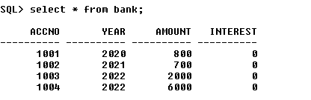

declare

cursor c1 is select * from bank;

begin

for i in c1

loop

if i.amount<=1000

then

update bank set interest=i.amount*0.1 where accno=i.accno;

elsif i.amount>1000 and i.amount<=5000

then

update bank set interest=i.amount*0.2 where accno=i.accno;

else

update bank set interest=i.amount*0.3 where accno=i.accno;

end if;

end loop;

end;

/

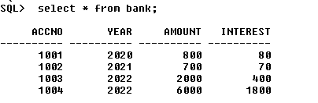

1. **Calculate Electricity Bill Using Cursors**

create table electricity(billno int,name varchar(25),unit int,charge float);

insert into electricity values(2001,'ajayan',75,0);

insert into electricity values(2002,'abhirami',200,0);

insert into electricity values(2003,'emily',150,0);

insert into electricity values(2004,'anitta',250,0);

insert into electricity values(2005,'bibin',100,0);

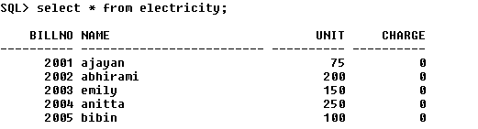

declare

cursor c2 is select * from electricity;

begin

for i in c2

loop

if i.unit<=100

then

update electricity set charge=100+i.unit*0.2 where billno=i.billno;

elsif i.unit>100 and i.unit<=200

then

update electricity set charge=100+i.unit*0.4 where billno=i.billno;

else

update electricity set charge=100+i.unit*0.5 where billno=i.billno;

end if;

end loop;

end;

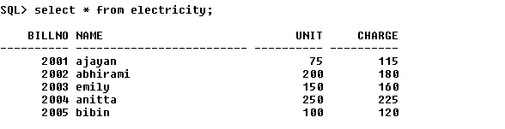

1. **Write PL/SQL code to UPDATE values in created tables by using Implicit Cursors.**

declare

r int;

begin

if sql%notfound

then

dbms_output.put_line('Not updated');

else

update item set price=100;

r:=sql%rowcount;

dbms_output.put_line('Price for '||r||' items updated');

end if;

end;

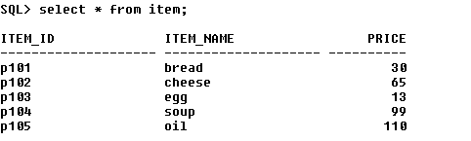

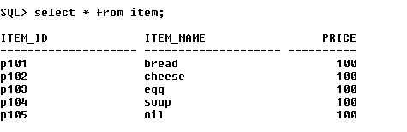

**4.Given the table works(emp_id,company_name,salary).write a cursor to**

**select the three highest paid employees from the table.**

create table workers(emp_id int,company_name varchar(25),salary int);

insert into workers values(101,'tcs',25000);

insert into workers values(102,'tcs',30000);

insert into workers values(103,'wipro',40000);

insert into workers values(104,'wipro',20000);

insert into workers values(105,'infosys',38000);

declare

i int:=0;

cursor c5 is select * from workers order by salary desc;

r c5%rowtype;

begin

open c5;

loop

exit when i=3;

fetch c5 into r;

dbms_output.put_line(r.emp_id||' '||r.company_name||' '||r.salary);

i:=i+1;

end loop;

close c5;

end;

